Interview page 4

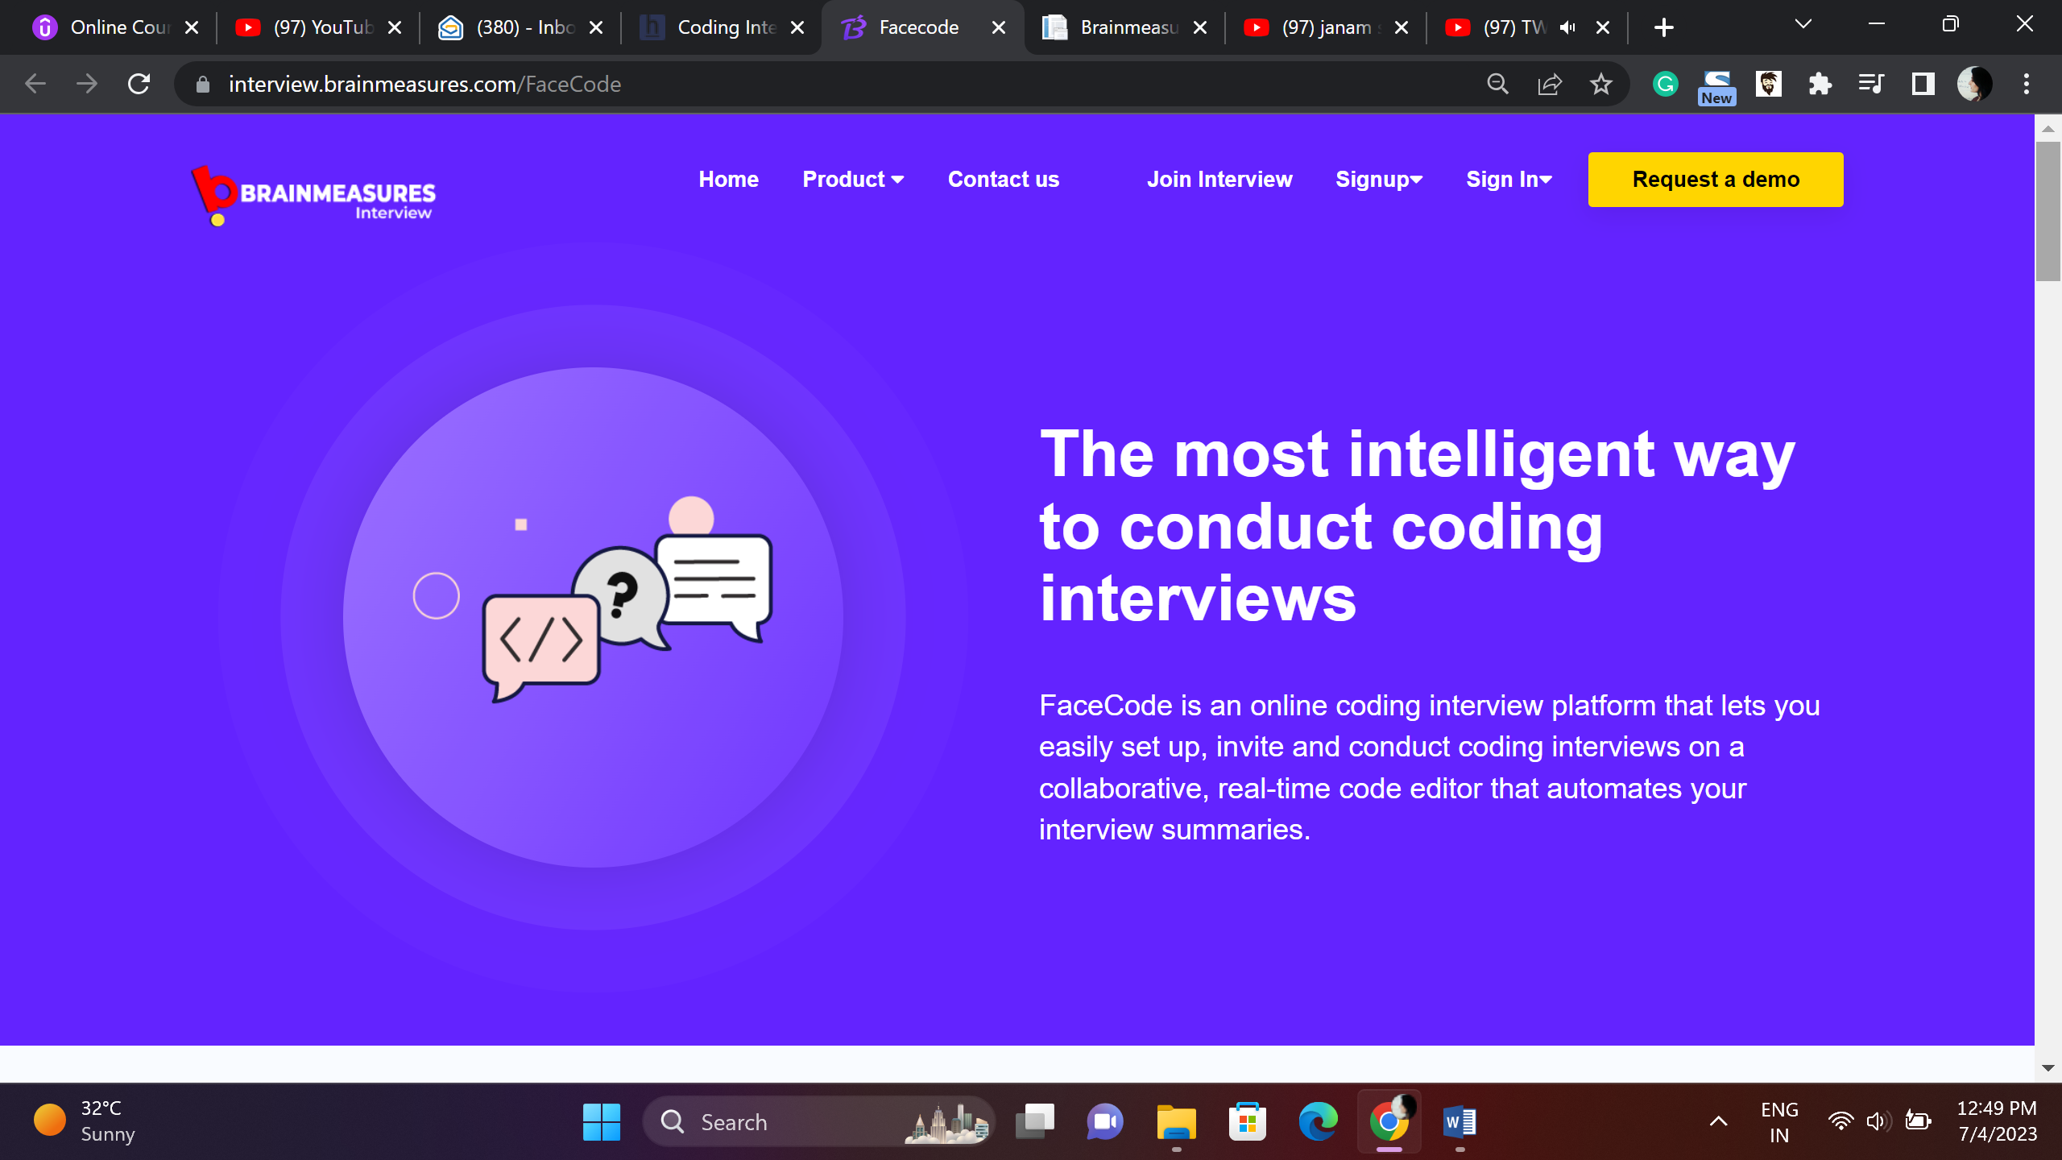

Coding Interviews – Choose Brainmeasures an Intelligent way to Hire Right

Brainmeasures online coding interview platform is the smart way to conduct hassle free online coding interviews, easy to set-up and convenient user interface, real time code editor and in-depth anyaltic reports makes technical hiring easy and effective.

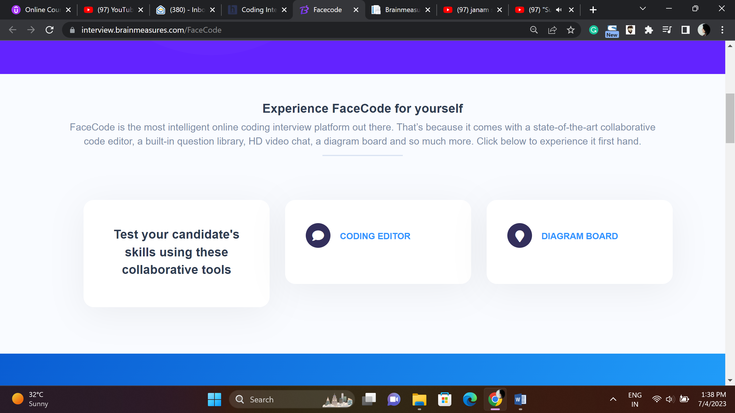

**Explore it and Notice the difference firsthand**

Brainmeasures online coding interview platform uses state of art technology and ready to use question library makes Brainmeasures first choice of recruiters, use it to experience the tech magic.

Test your candidate’s skills coding editor Diagram Board

Using collaborative tools

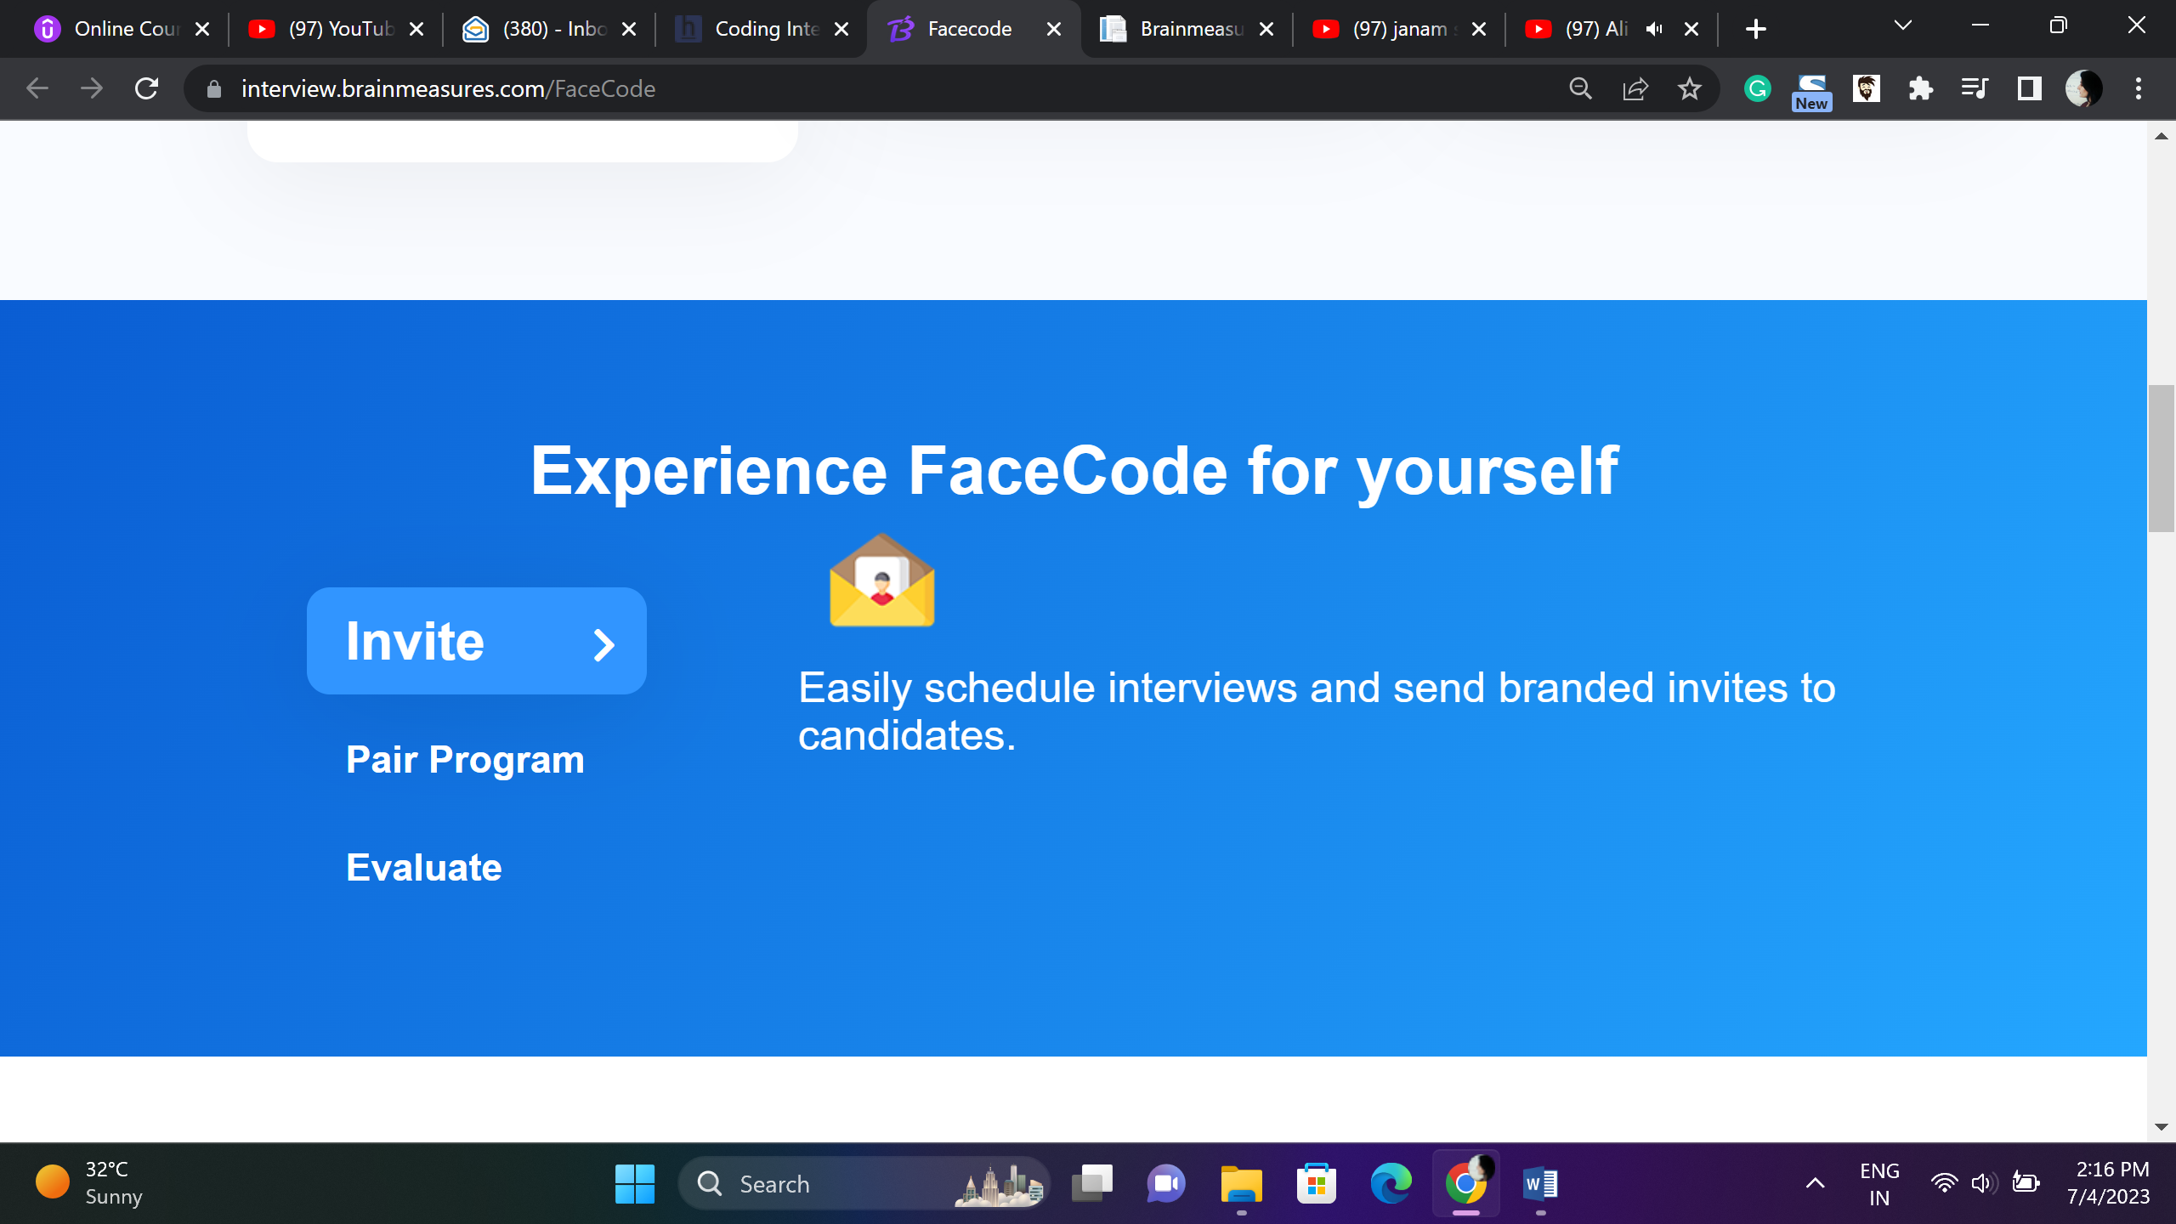

**This content is ok**

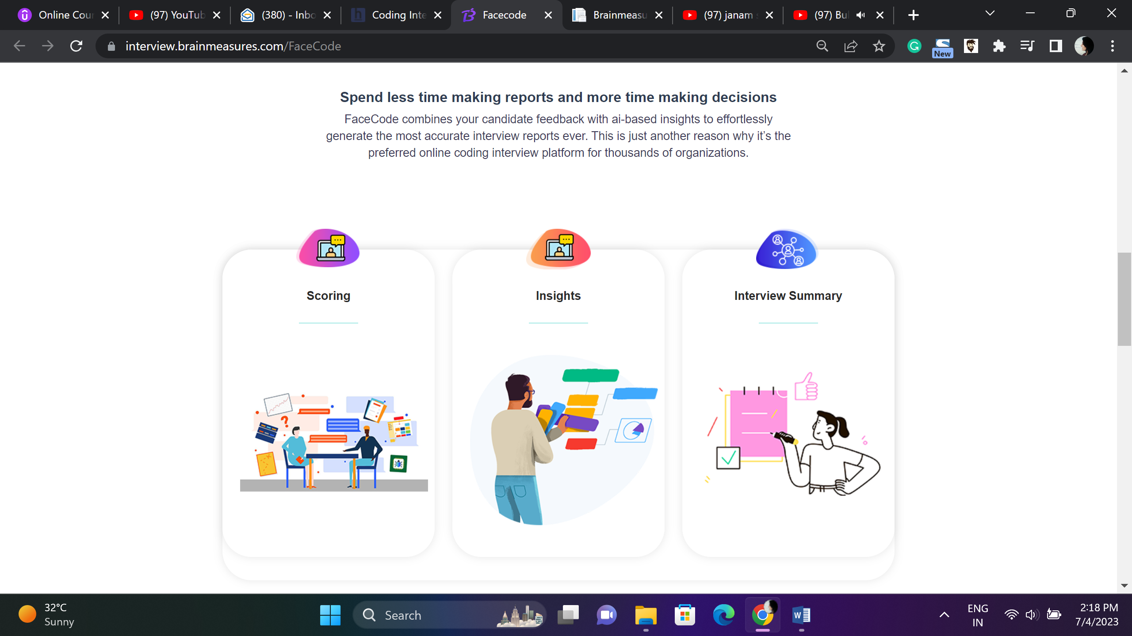

**Spend More time in Productive Decision Making, Leave report making to us**

**Brainmeasures hi tech systems combine and generates advanced, in-depth result reports of each candidate who appeared for online interview, reports are presented in visually easy to understand reports helping you make right hiring decisions.**

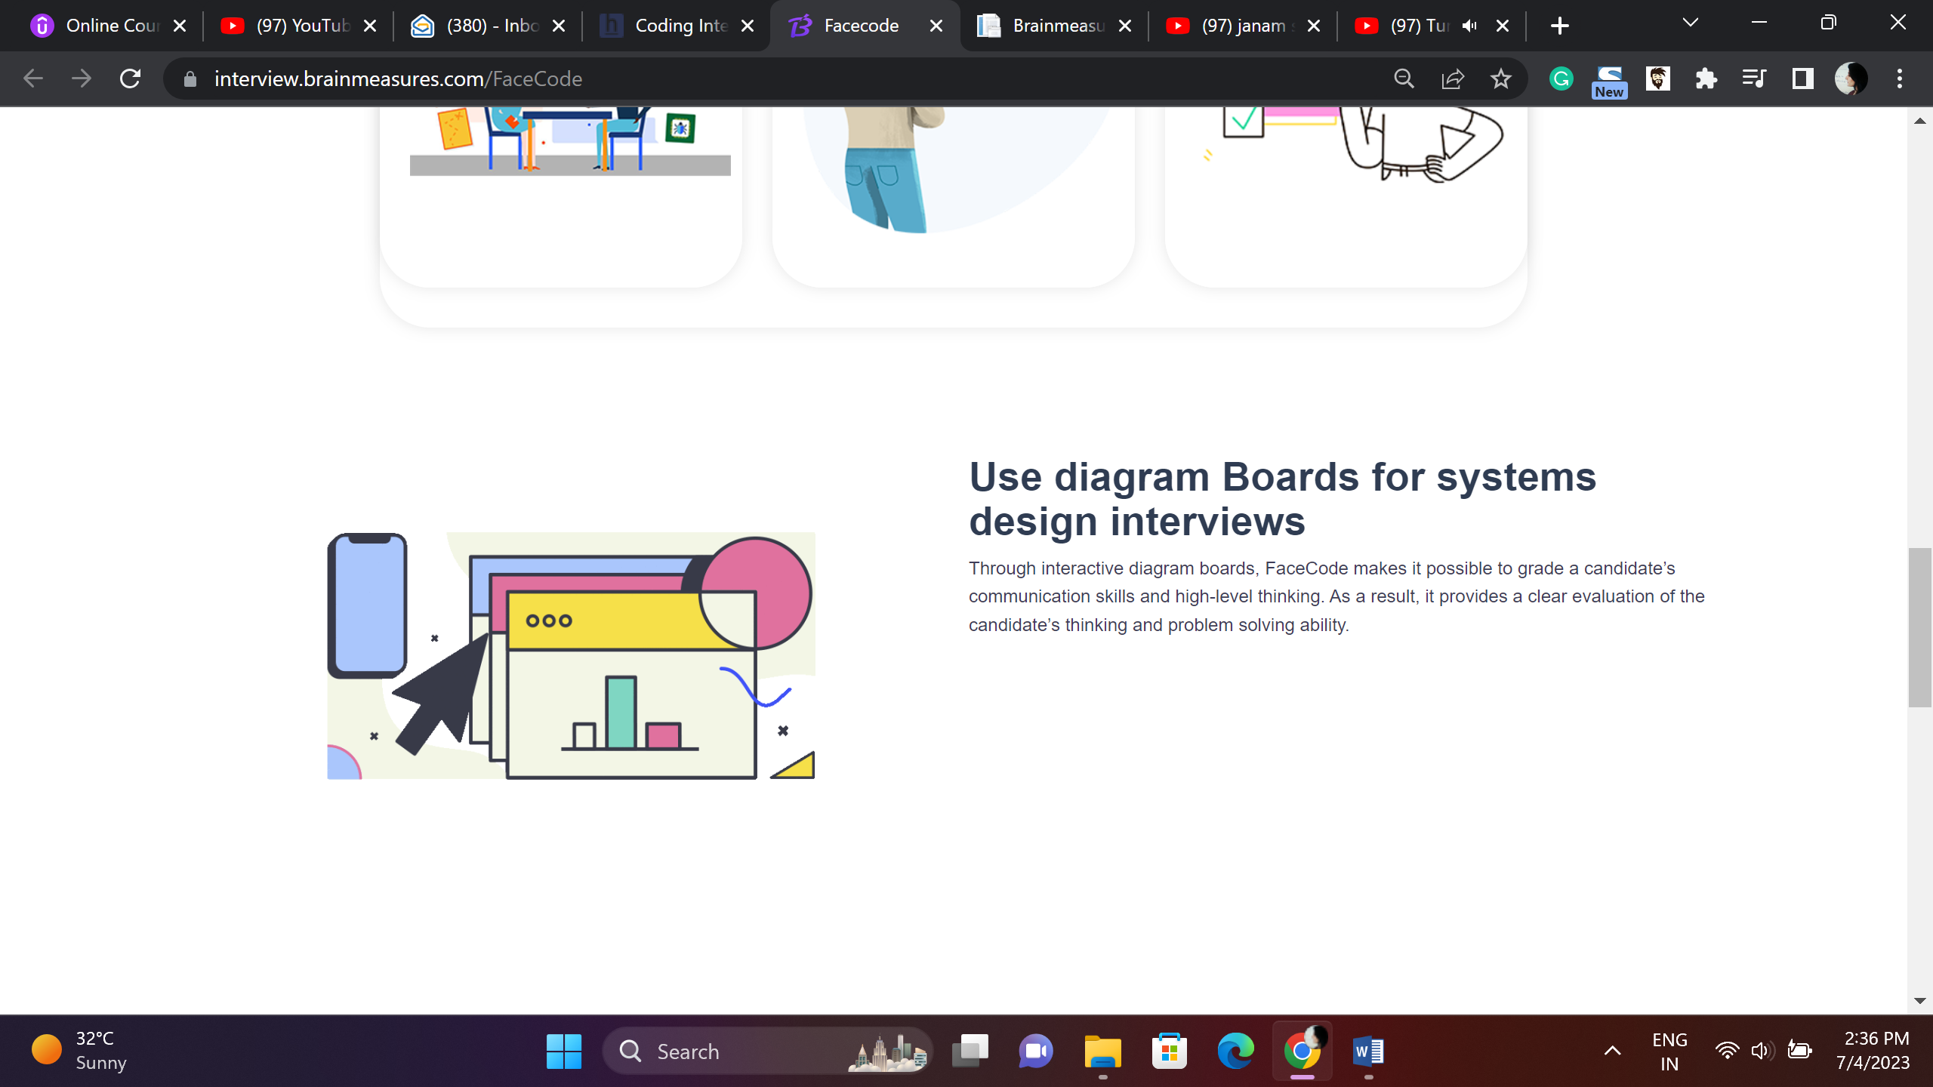

**Conducting System Design Interviews – Try Brainmeasures Diagram Boards.**

**Get in-depth insights into candidate’s communication and thinking skills, evaluate their problem solving ability using Brainmeasures Diagram Boards.**

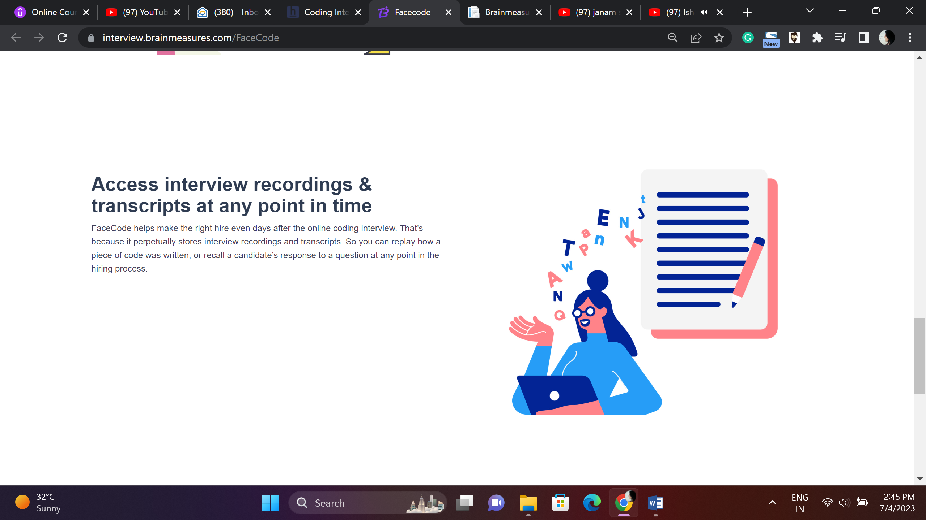

**Recorded Interviews and Analytic Reports**

**Brainmeasures uncomplicates hiring decisions, online interviews are recorded for later reference, use recorded interviews and analytic reports to select best people for your organization.**

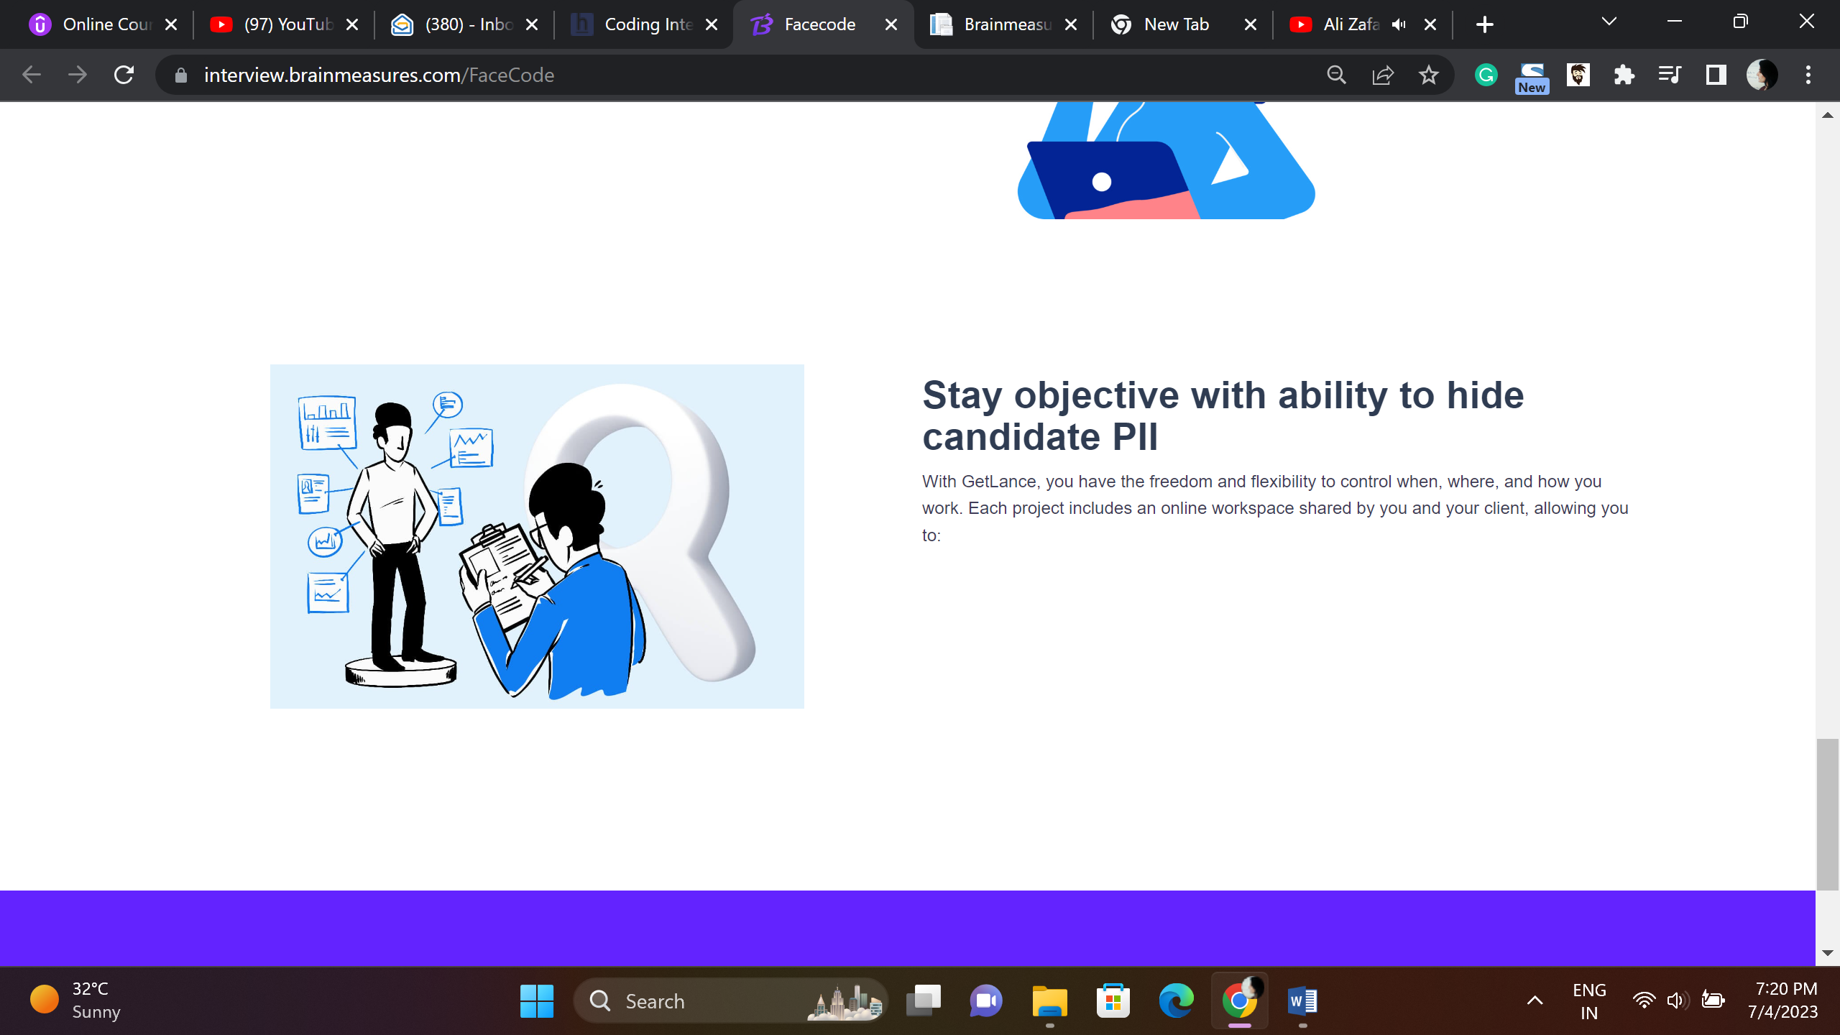

**Hide Candidate Personally Identifiable Information (PII) – Stay Objective**

**Our laser sharp focus is to create a platform that empowers you to choose and retain talent, our system is loaded with all the advanced features like ability to hide candidate PII that help you make objective and accurate hiring decisions.**

